Go to parklands.co.uk via your chosen web browser
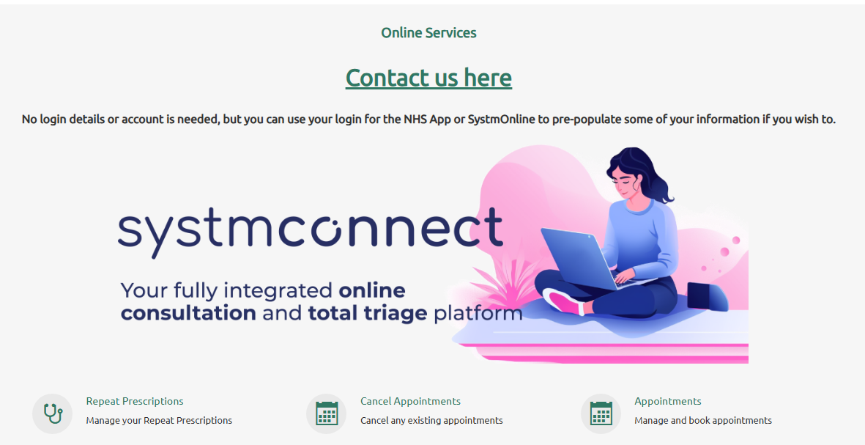
Scroll down on the home page and you will find the image below.

You can click Contact us here or on the image of the lady holding a laptop which will take you SystmConnect page (see image below)
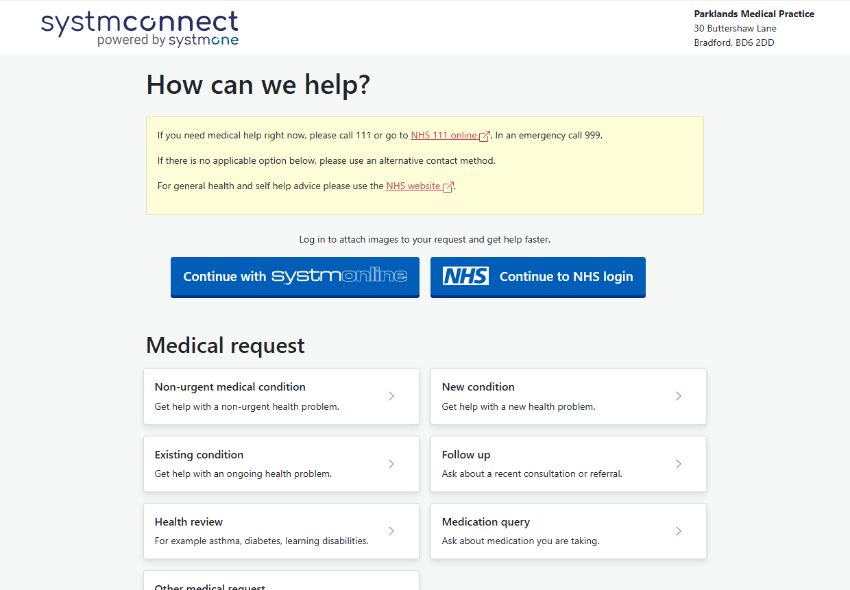
You do not need a username or password to send a SystmConnect request. You can simply click on the type of request and fill the form in. (You will be asked for name, dob NHS number etc)

If you do have a SystmOnline account or NHS login then you can use this to sign in which will prepopulate your information.

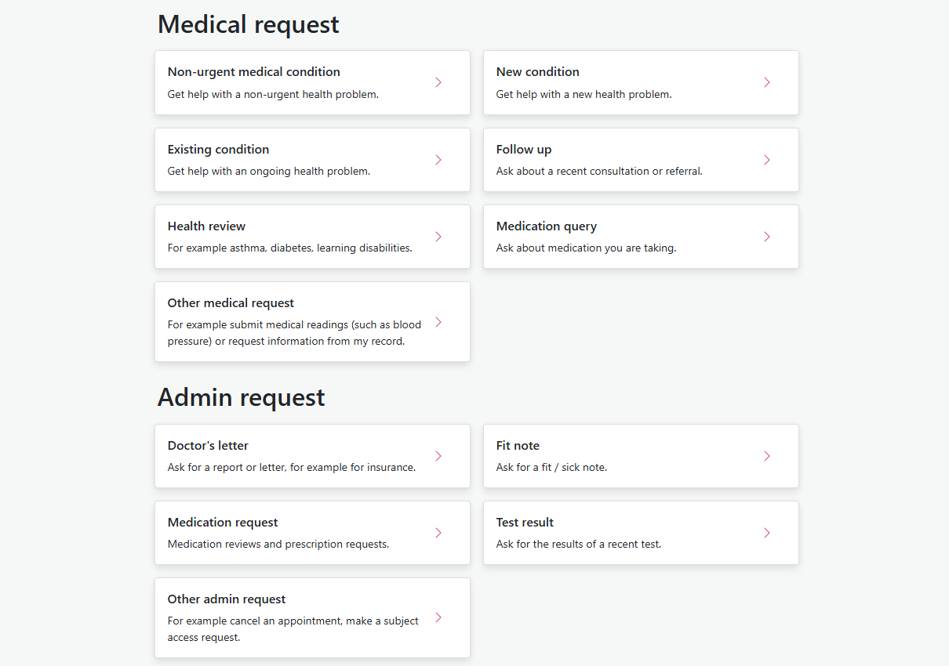
Once your request has been sent you will receive a confirmation. Our triage team will then review your request and be in touch.

